COS225 Assignment #5 Name ___________________________
Due: Friday 3/9/18
Late: Friday 3/23/18
Readings: Chapter 20 and queue lectures

Create a Word or RTF or PDF document (no other formats please) with answers to Part I questions and screen shots of program output.

Part I: (20 pts.)

1. (2) When using a singly linked list to implement a queue, the ____ should be the front of the queue.

a. head node
b. tail node
c. neither the head node nor the tail node
d. either head node or tail node as both implementations have the same efficiency

2. (2) When using a singly linked list to implement a queue, the ____ should be the rear of the queue.

a. head node
b. tail node
c. neither the head node nor the tail node
d. either head node or tail node as both implementations have the same efficiency

3. (2) The LinkedQueue class throws the EmptyCollectionException exception during _________ operation(s).

a. enqueue b. dequeue
c. getFront d. enqueue and getFront
e. dequeue and getFront

4. (2) Any application that could be solved using the handwritten ArrayQueue class could also be solved using the handwritten LinkedQueue class.

a. True b. False

5. (2) The Java Queue interface offers a method named _________ to insert an element to the rear of the queue.

a. add b. enqueue c. insert d. poll

6. (2) Indicate all of the situations that suggest FIFO behavior in a word processor program. There may be more than one correct answer.

a. Issuing five File / Print commands in succession
b. Using Edit / Undo to remove the command done two steps ago
c. Using File / Open / Recent to reopen the most recent file saved
d. Repeatedly pressing the Bold button to turn boldfacing on and off

7. (2) The ______________ collection in the Java Collections Framework stores objects that are processed in order of importance by some data member.

a. List
b. Queue
c. PriorityQueue
d. Stack

8. (2) Fill in the code to create a reference named c of the generic Collection interface of type String and instantiate with a LinkedList object.

____________________________________________

9. (4) Using the refence named c in Question #8, indicate all methods that may be called. There may be more than one correct answer. Note only the method name is listed in the choices.

a. c.substring
b. c.add
c. c.contains
d. c.trimToSize
e. c.removeFirst

Part II: (80 pts.)

This program will use built-in Java classes in the game of Fox, Chicken, and Grain. In this game there is farmer on the south bank of a river who needs to transport a fox, chicken, and grain to the north shore. The boat is only large enough for one item or the farmer can travel alone. If the fox is left alone with the chicken, the fox will eat the chicken. If the chicken is left alone with the grain, the chicken will eat the grain. The game is won if the farmer and all three items end up on the north bank.

1. The FoxGame specification is presented below. Complete the methods of this class without changing the PRE/POST comments. Decide which type of collection is appropriate for this problem. Write an InvalidExceptionCollection class which reports message "Invalid Transport Value" when caught.

public class FoxGame {

String farmerLocation; // location of farmer: south or north
____________________ // items on south bank
____________________ // items on north bank

public FoxGame ( ) // POST: Add three items to south bank
{ } // Place farmer on south bank
// North bank is empty

public boolean won ( ) // POST: return true if game won
{ }

boolean lost ( ) // POST: return true if the game lost
{ }

public boolean found (String item) // POST: return true if item is on current bank
{ } or item is "none"

public void transport (String item) throws InvalidCollectionException
{ } // PRE: item is on current bank or string "none"
// POST: item removed from current bank
// added to opposite bank
// farmer is now on opposite bank

public String getFarmerBank ( ) // POST: return bank holding farmer: north/south
{ }

public String getOtherBank ( ) // POST: return bank not holding farmer
{ }

public String displaySouthBank ( ) // POST: return contents of south bank
{ }

public String displayNorthBank ( ) // POST: return contents of north bank
{ }
} }

2. Write a class A5FoxGame which creates a FoxGame object and plays the game. Use the try/catch mechanism to assist in error checking when the PRE condition of the transport method is violated.

Screen shot #1 to submit: This example illustrates catching an invalid transport item "grape".

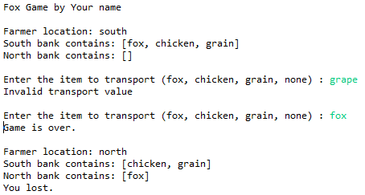

Screen shot #2 to submit: This example illustrates catching an invalid transport item that is one of the four items but does not exist on the current bank.

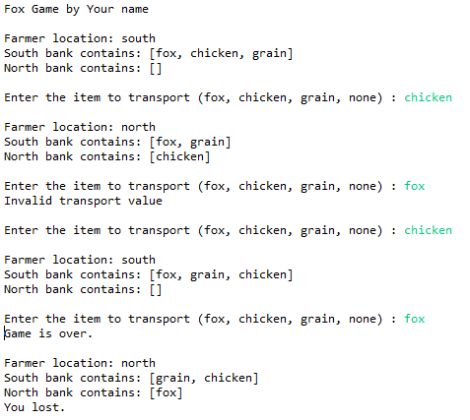

Screen shot #3 to submit:
Turn in a screen shot of a winning solution. You do not need to show any error messages.

